POJOs AUTOMATION

Introduction

Both Hibernate mapping files and POJOs (Plain Old Java Objects) are automatically generated by reverse engineering for a given database schema. Customized Templates are used in POJOs automation process.

Hibernate Tools is a toolset for Hibernate 3 and related projects. The tools provide Ant tasks and Eclipse plug-in for performing reverse engineering, code generation, visualization and interaction with Hibernate.

Download and add Hibernate Tools plugin
Download appropriate Hibernate tools version:
Base URL: www.hibernate.org-->Hibernate tools --> JBoss Tools --> (Select) Downloads--> Stable Releases

Eclipse Version | Hibernate tools version
Helios (3.6) | 3.2.2
Indigo (3.7) | 3.3.2
Juno (4.2) | 4.0.1
Kepler (4.3) | 4.1.0.1

Extract hibernate tool content and copy hibernate tool plug-ins and features to eclipse dropins and features directory respectively. Now restart the eclipse. Following steps are used for doing reverse engineering.
Note: Once after restart eclipse, ‘Hibernate’ is added in New→Other indicates hibernate plug-ins are added successfully.
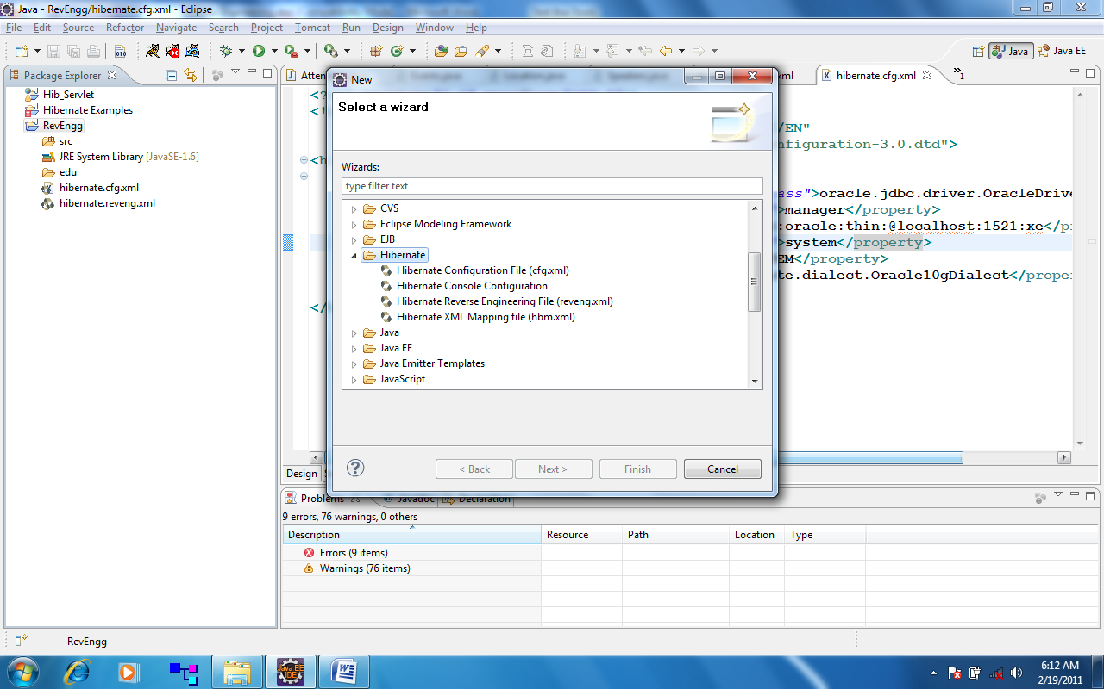

Step I: Creating Hibernate Configuration File
The Hibernate Tools provide a wizard for generating the hibernate.cfg.xml file if we do not already have such file.

Start the wizard by clicking "New Wizard" (Ctrl+N) or New→ Other→ Hibernate, select the Hibernate Configuration file (cfg.xml).

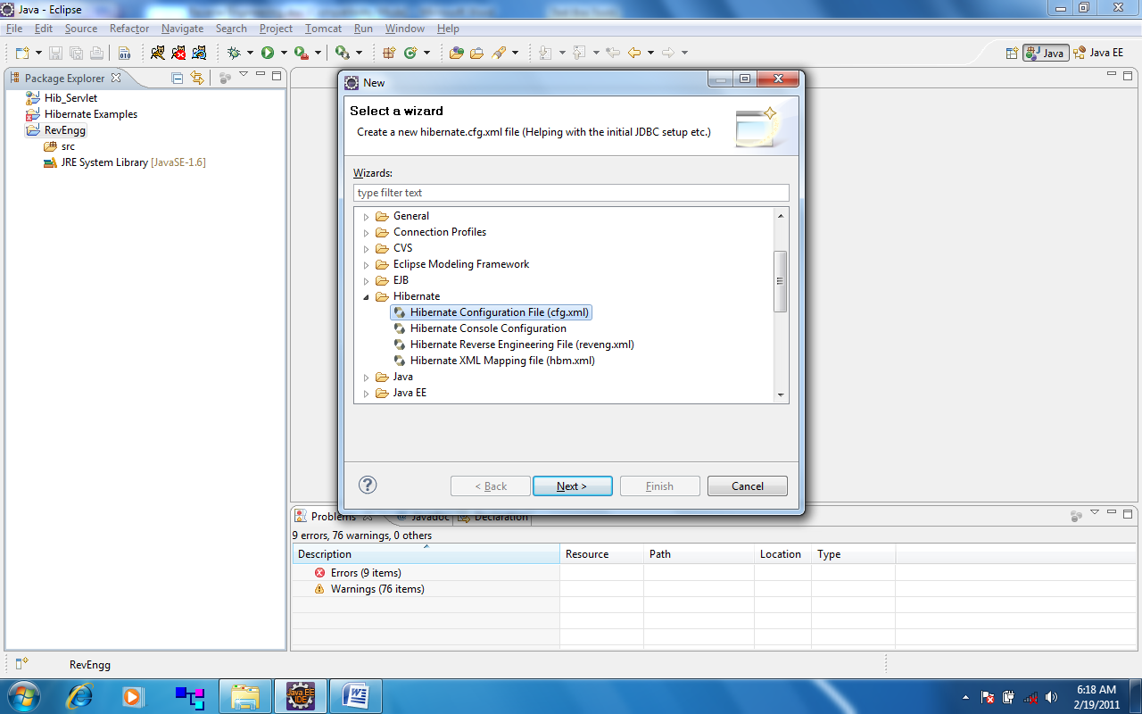

Figure 1 Hibernate Configuration Wizard.

After selecting Hibernate Configuration file (cfg.xml), click on Next button.
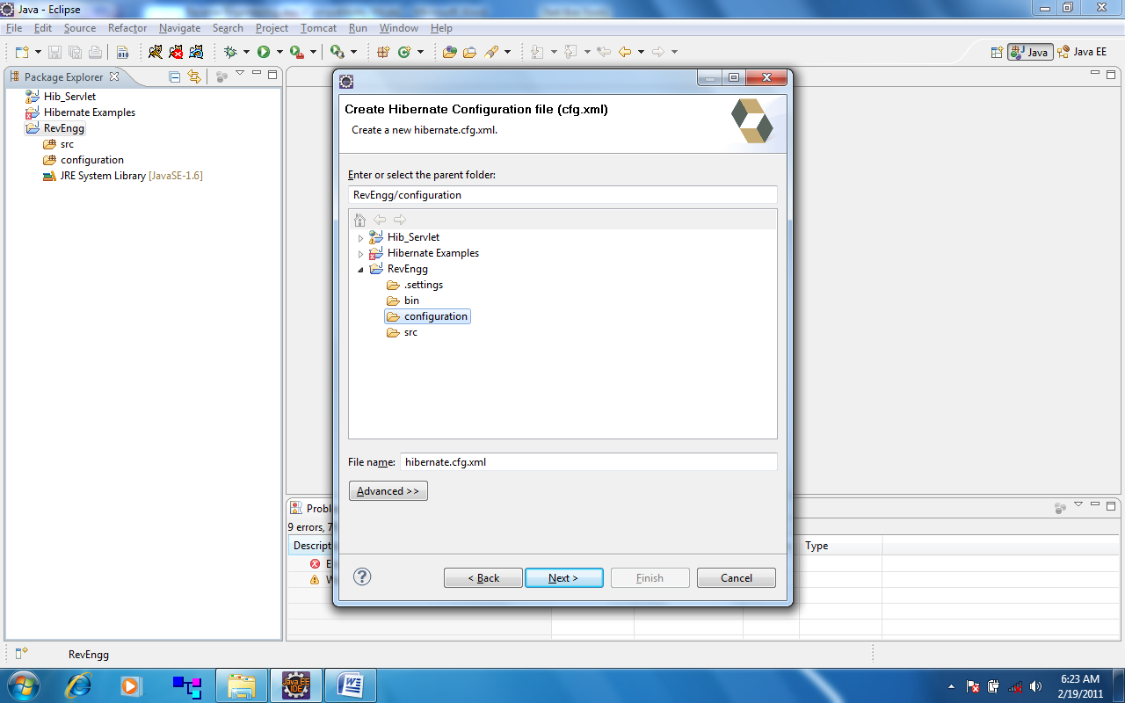

Figure 2 Hibernate Configuration Wizard.

After selecting the destination location for the hibernate.cfg.xml (or hibernate_oracle.cfg.xml) file, we will see the following screen shot

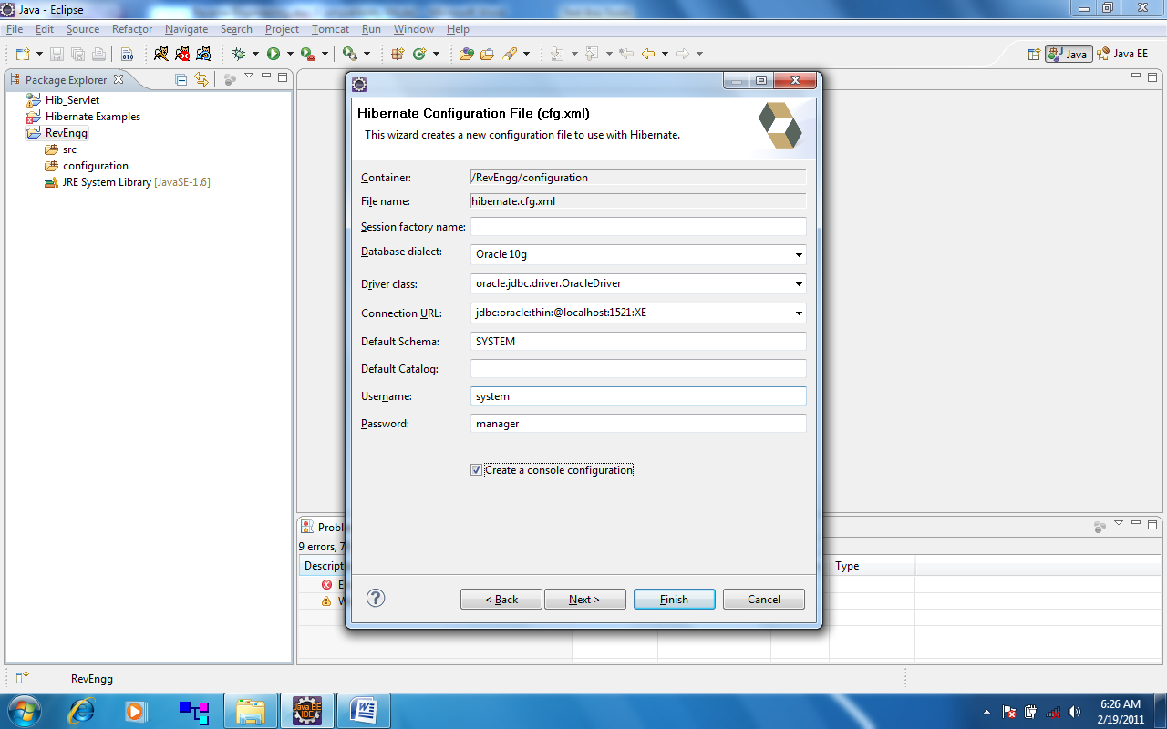

Figure 3 Hibernate Configuration Wizard.
Note: Enable ‘Create a console configuration checkbox.

Step II: Creating a Hibernate Console configuration

A Console Configuration describes to the Hibernate plug-in how it should configure Hibernate and what configuration files, including which class path is needed to load required jars such as JDBC drivers etc.
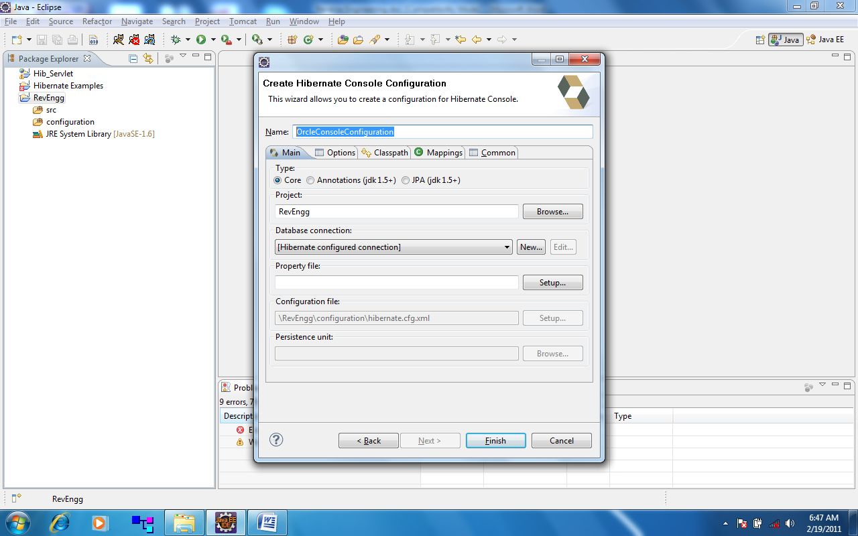

Figure 4 Console Configuration Wizard

We create a console configuration by running the Console Configuration wizard (clicking "New Wizard" (Ctrl+N), shown in the above screenshot. The same wizard will also be used if we are coming from the hibernate.cfg.xml wizard and had enabled "Create Console Configuration".
The dialog consists of Classpath tab for adding required jar files.
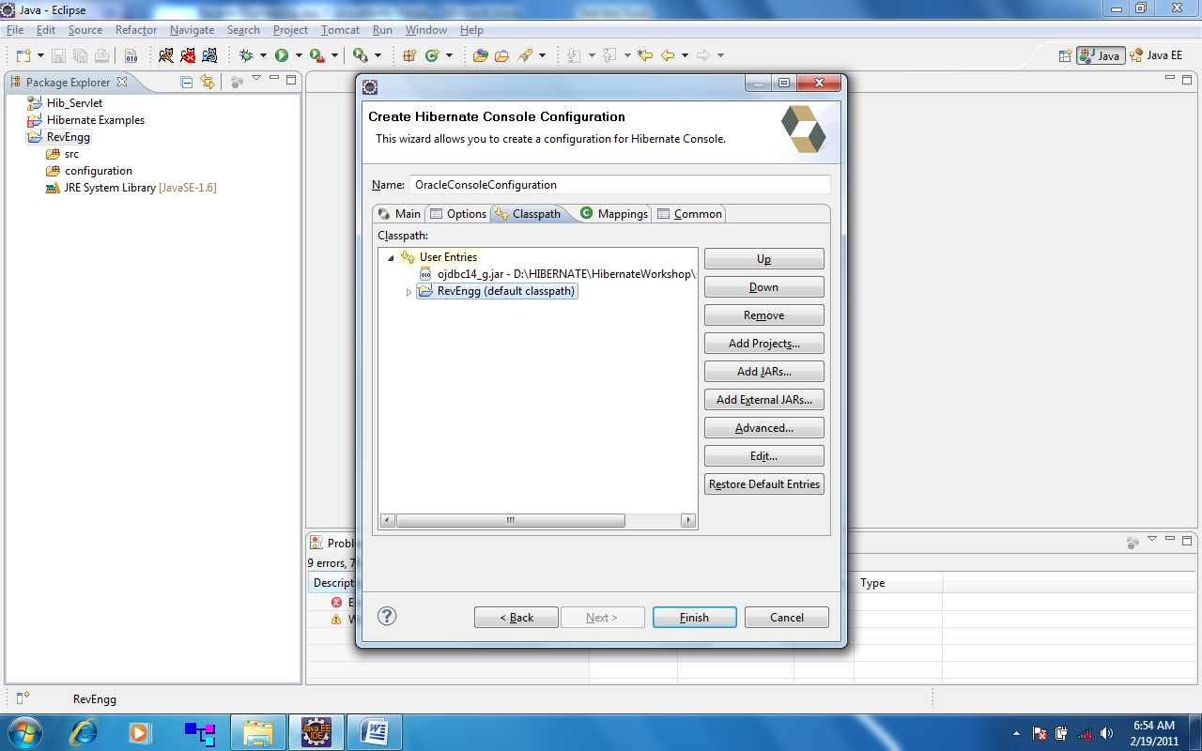

Figure 5 Hibernate Console Configuration classpath.

Step III: Reverese Engineering File
Start the wizard by clicking "New Wizard" (Ctrl+N) or New→ Other→ Hibernate, select Hibernate Reverese Engineering file (reveng.xml).
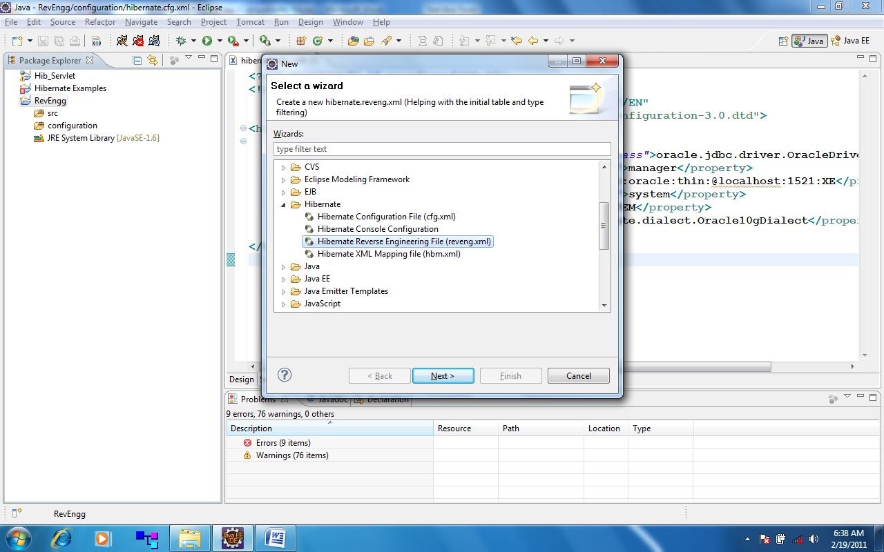

Figure 6 Hibernate Reverse Engineering

After selecting reveng.xml file, press "Next". We will see the following screen shot

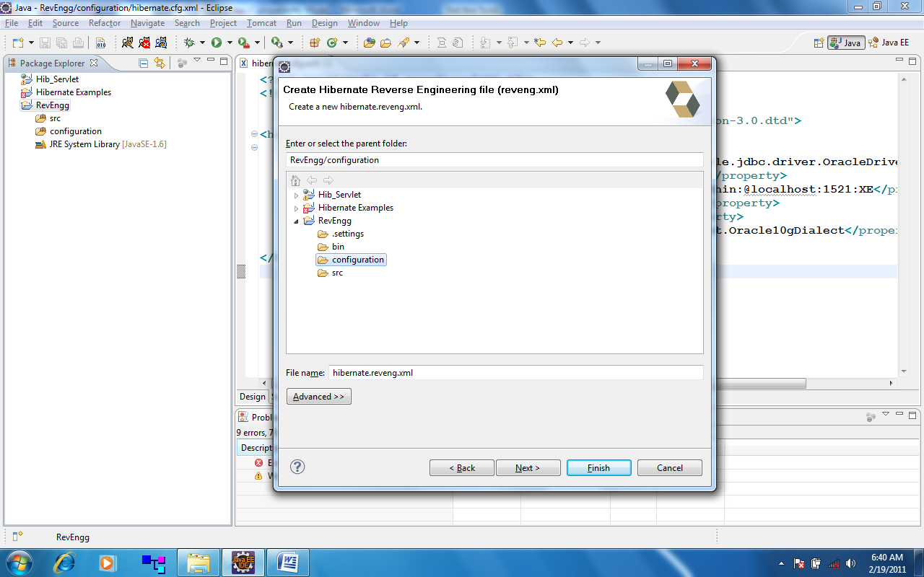

Figure 7 Hibernate Reverse Engineering

Choose reverse engineering file name(such as hibernate.reveng.xml), and press “Next” button. Select console configuration, and click on Refresh button. Following screen shot will be show.

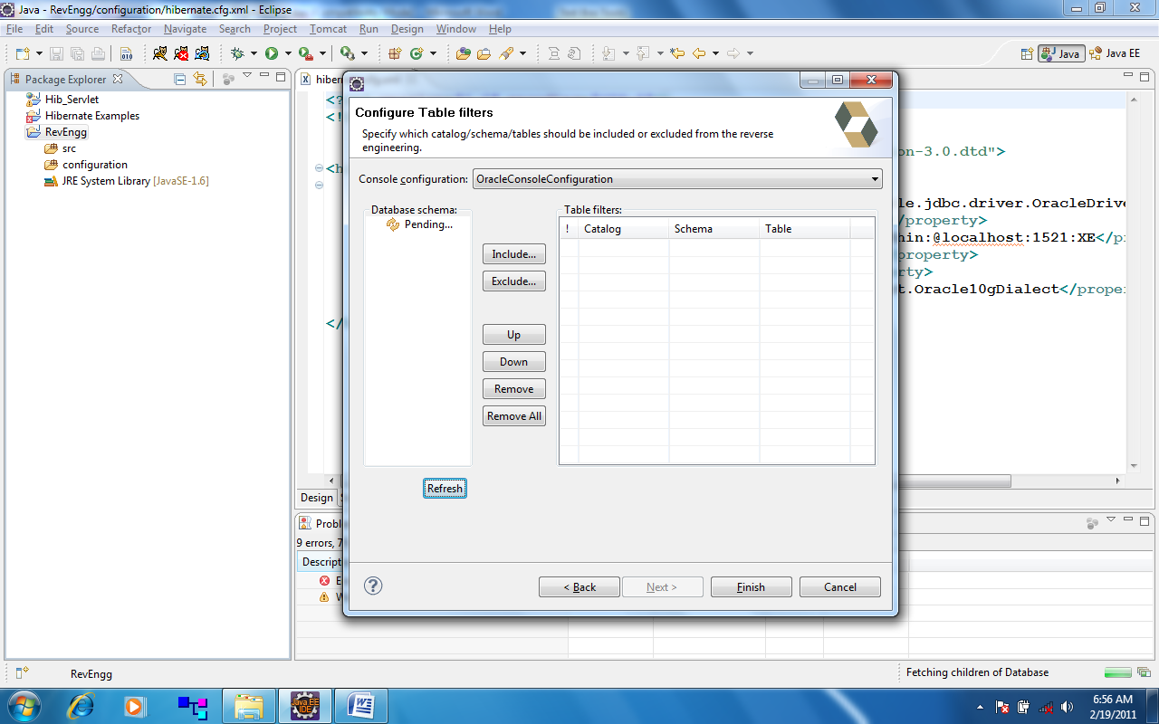

Figure 8 Hibernate Reverse Engineering.

Choose appropriate console configuration as shown above, and then click on Refresh button.
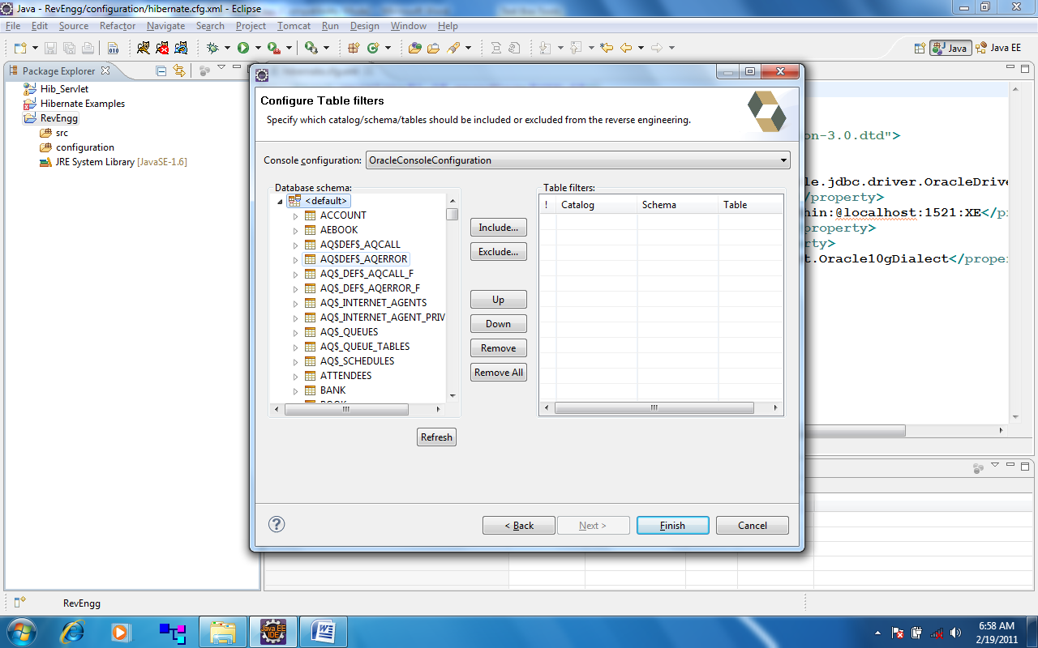

Figure 9 Hibernate Reverse Engineering.

Choose appropriate database schema, select required database tables, include them into the right side of the figure and then click on Finish button.
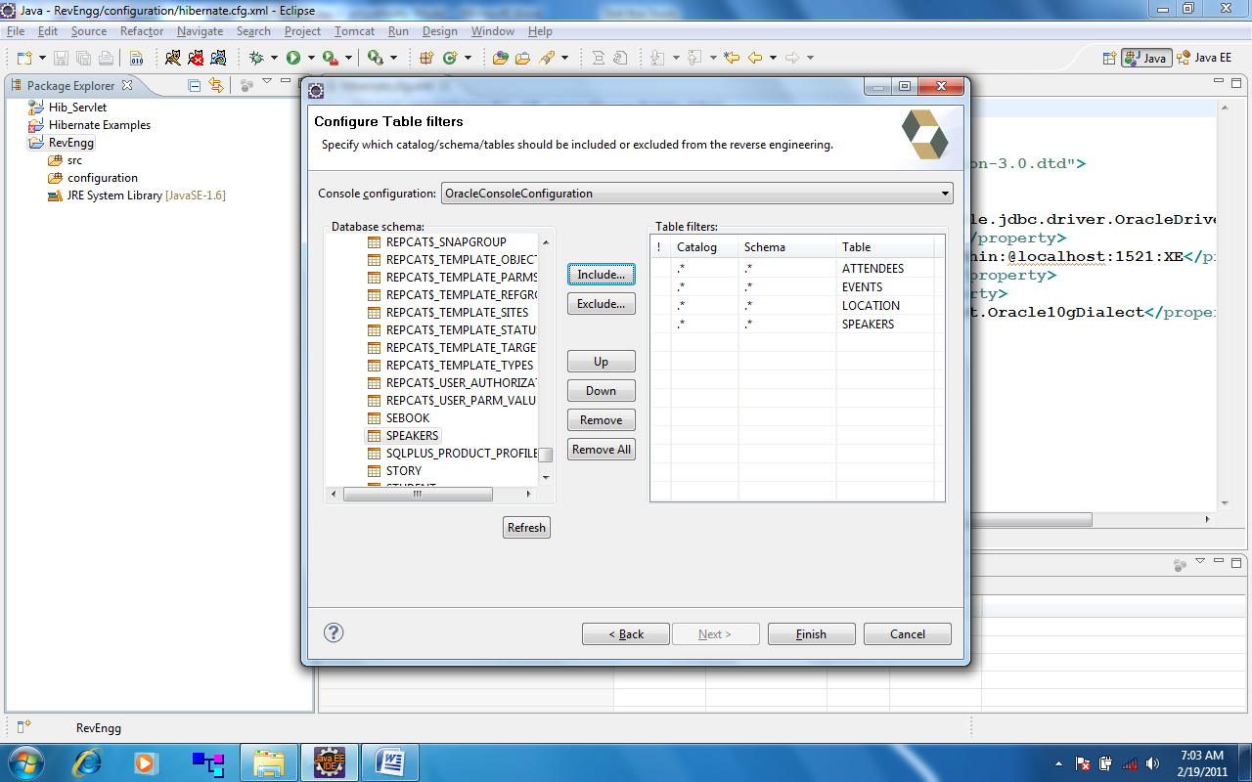

Figure 10 Reveres Engineering.

Step IV: Hibernate Code Generation

Select Run→ Hibernate Code Generation…→ Open Hibernate Code Generation…Dialog→ Click on New launch configuration Or Right click on Hibernate Code Generation

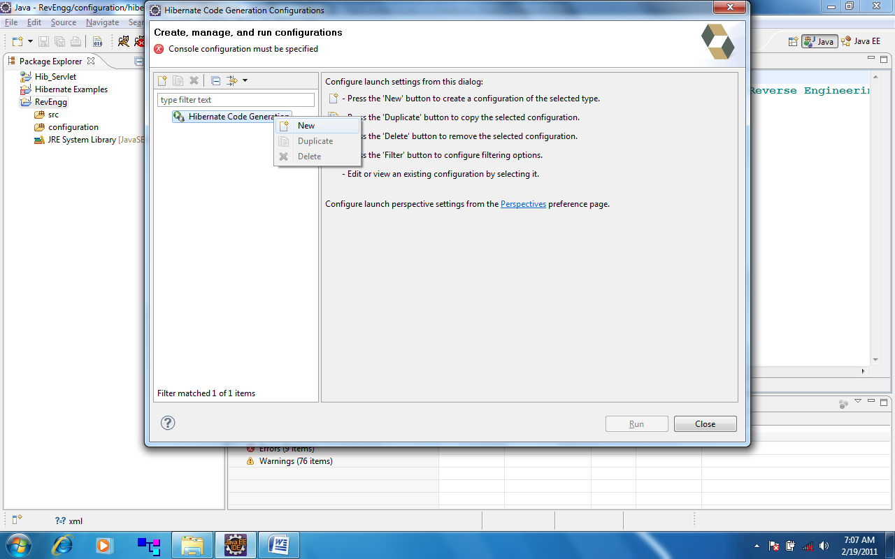
Figure 11 Hibernate Code Generation.

Provide required details.

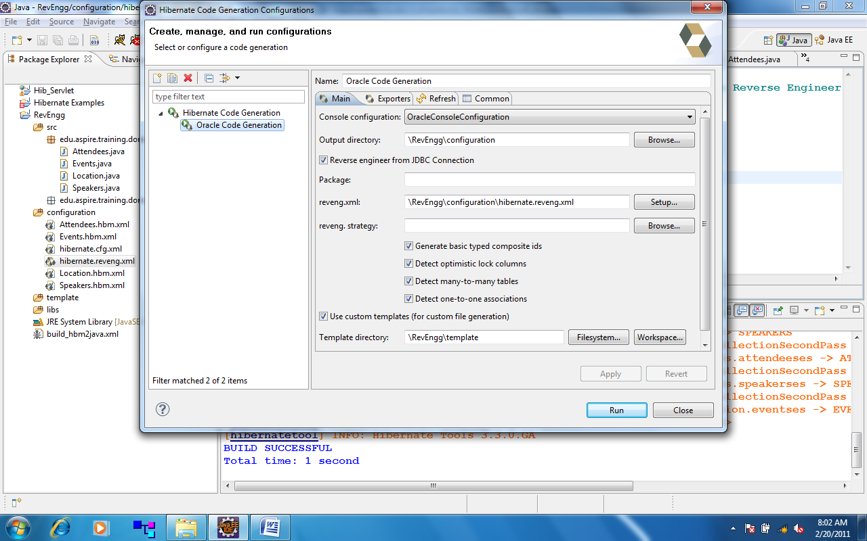

Figure 12 Hibernate Code Generation Screen Shot.

Choose template(Optional) for customizing hibernate mapping files such as including <meta tag etc.

The Exporters tab specifies the type of code that should be generated. Each selection represents an 'Exporter,' responsible for generating the code. Check the option for 'Use Java 5 syntax' and click on 'Run.' The classes will be generated in the specified output directory.

Exporters tab
The Exporters tab contains seven options categorized in two groups. The first group contains two options-Use Java 5 syntax and EJB 3 Annotations. As the name suggests, the first option creates POJOs using JDK 1.5 syntax constructs only, while the second option creates classes with EJB 3 syntax using annotations.

The second group has five options: Domain Code (.java) that creates POJOs for all the persistent entities and components; Hibernate XML Mappings that generates Hibernate mappings for each entity in the database; DAO code (.java) option that creates a set of DAO for the entities; Hibernate XML Configuration generates hibernate.cfg.xml file that keeps Mappings updated; Schema Definition (.html) that generates HTML docs which document the database schema; and JBoss Seam Skeleton App [beta] (misc) that creates the Seam skeleton app including annotated POJOs, Seam controller Beans, a JSP Presentation layer, and a Build.xml file. Since the option generates the entire application, you should configure the root dir of your project as the target output dir.

Choose Exporters tab, Check on Use java 5 Syntax.

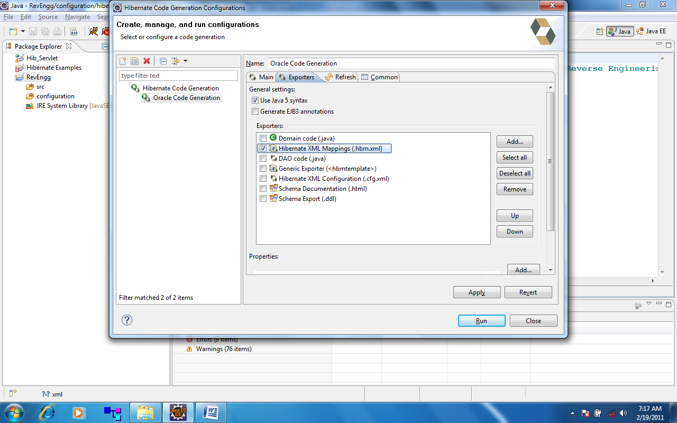

Figure 13 Exporters tab in Hibernate Code Generation wizard.

Hibernate XML mappings(.hbm.xml) exporter option..

Click on “Apply” and then on “Run” button.
Hibernate mapping files are generated in the chosen path.

Suggested Links:

http://www.hibernate.org/hib_docs/tools/reference/en/html_single/#setup

ANT Script for POJOs Automation

Write ant script, and saved as build_hbm2java.xml

<project name="POJO Generation Using Hibernate Tool" default="hbm2java">
<target name="hbm2java">
<property name="base_dir" value="./" />
<property name="jar.dir" value="libs" />
<path id="toolslib">
<path location="${jar.dir}/hibernate-tools.jar" />
<path location="${jar.dir}/hibernate3.jar" />
<path location="${jar.dir}/commons-logging-1.0.4.jar" />
<path location="${jar.dir}/dom4j-1.6.1.jar" />
<path location="${jar.dir}/commons-collections-3.1.jar" />
<path location="${jar.dir}/freemarker.jar" />
<path location="${jar.dir}/slf4j-api-1.5.8.jar" />
<path location="${jar.dir}/slf4j-jdk14-1.5.8.jar" />
</path>
<taskdef name="hibernatetool" classname="org.hibernate.tool.ant.HibernateToolTask" classpathref="toolslib" />
<hibernatetool destdir="${base_dir}/src">
<configuration>
<fileset dir="${base_dir}/configuration">
<include name="*.hbm.xml" />
</fileset>
</configuration>
<hbm2java jdk5="true" templatepath="${base_dir}/template"/>
</hibernatetool>
</target>
</project>

Execution:

Right click on build_hbm2java.xml → Run As → Ant Build

O/P: POJOs are created in the destination folder.

